

# Project Topic: --------------------------------------

### Name of Department:------------------ Name of Teacher: ------------------------ Subject: ----------------------

**Section: -------------**

## Group Members:

**Name:------------------- ID: -------------------------**

# Introduction:

This project report outlines the development of an online book store website using PHP, a popular server-side scripting language. The website aims to provide a convenient platform for users to browse, search, and purchase books. The project incorporates various features, including user registration and login, product catalog, shopping cart, payment processing, and order management.

**Project Objective:**

1. **Create a user-friendly interface:** Design an intuitive and visually appealing website that is easy to navigate.
2. **Implement a robust product catalog:** Allow users to search and browse a wide range of books, including categories, authors, and titles.
3. **Enable shopping cart functionality:** Provide a shopping cart system that allows users to add, remove, and view items before checkout.
4. **Integrate secure payment processing:** Offer multiple payment options, such as credit cards and online wallets, ensuring secure transactions.
5. **Manage orders and customer information:** Maintain a database of orders and customer details for efficient order processing and customer service.
6. **Provide a responsive design:** Ensure the website is accessible and functional across different devices and screen sizes.

**Project Methodology:**

**Requirements Gathering:**

* Identify the specific needs and expectations of the target audience.
* Define the scope of the project, including features, functionalities, and constraints.
* Conduct market research to analyze competitor websites and industry trends.

**2. Database Design:**

* Create a database schema to store information about books, users, orders, and other relevant data.
* Design tables, relationships, and indexes for efficient data retrieval and storage.

**3. Front-End Development:**

* Develop the user interface using HTML, CSS, and JavaScript.
* Create a visually appealing and responsive layout that enhances the user experience.
* Implement interactive elements, such as search bars, product galleries, and shopping cart functionality.

**4. Back-End Development:**

* Write PHP code to handle server-side logic and interact with the database.
* Develop functions for user registration, login, product catalog management, shopping cart operations, payment processing, and order management.
* Implement security measures to protect user data and prevent unauthorized access.

**5. Integration and Testing:**

* Integrate the front-end and back-end components to create a functional website.
* Conduct thorough testing to identify and fix bugs or errors.
* Test different scenarios and user flows to ensure the website works as expected.

**6. Deployment:**

* Deploy the website to a web server, making it accessible to users.
* Configure the server settings and database connections.
* Ensure the website is optimized for performance and search engine visibility.

### Technologies and Tools

* **Programming Language:** PHP
* **Database:** MySQL
* **Front-End Technologies:** HTML, CSS, JavaScript
* **Web Server:** Apache or Nginx
* **Development Environment:** Visual Studio Code,

**User Penal:**



**Products:**



**Signin:**

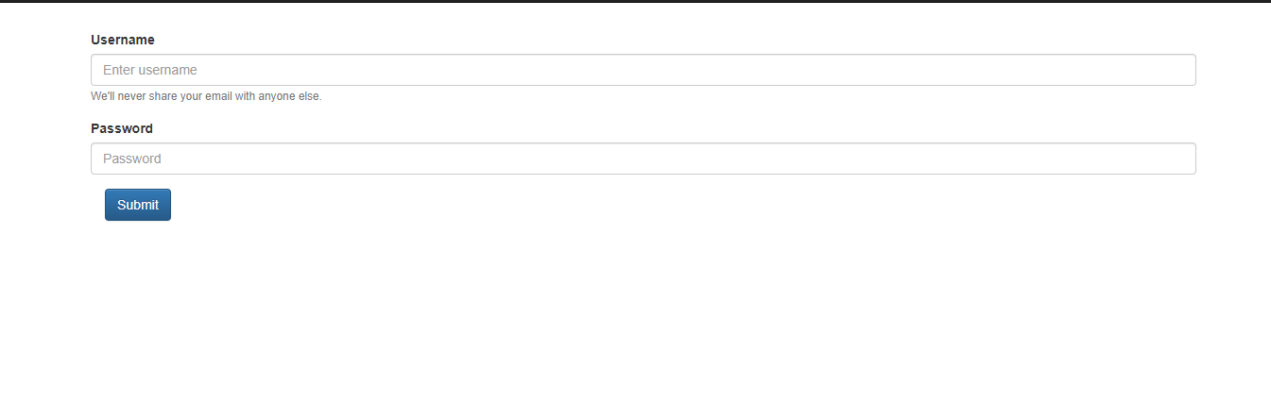

**Sign Up:**

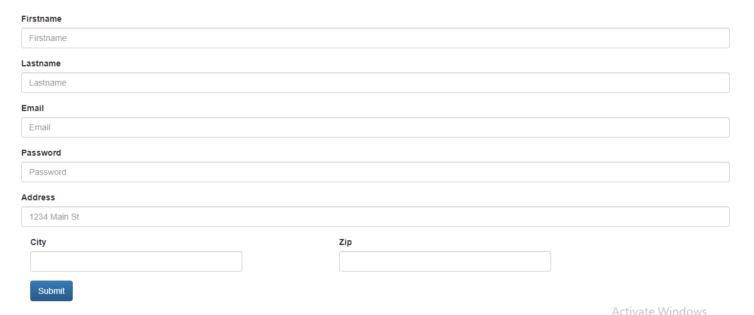



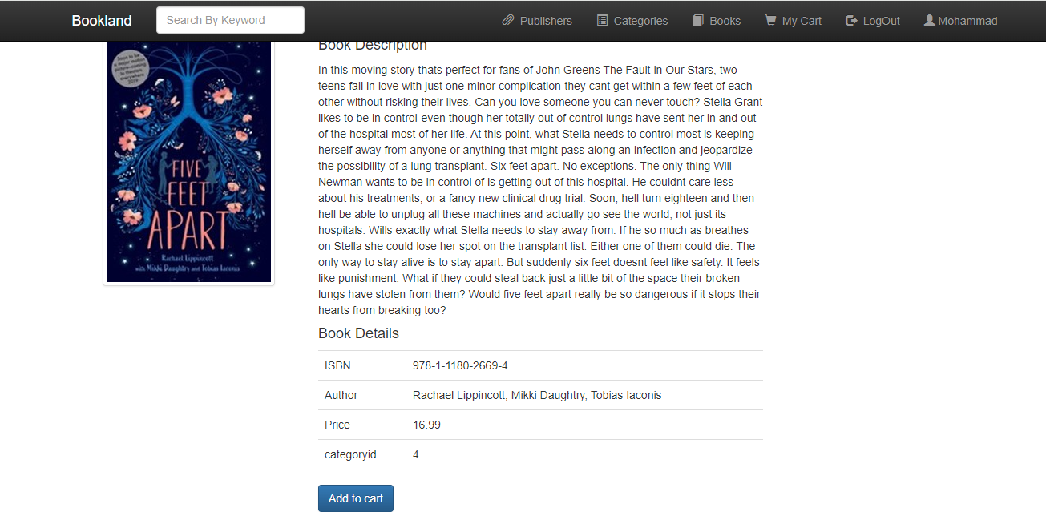**Add To Cart:**

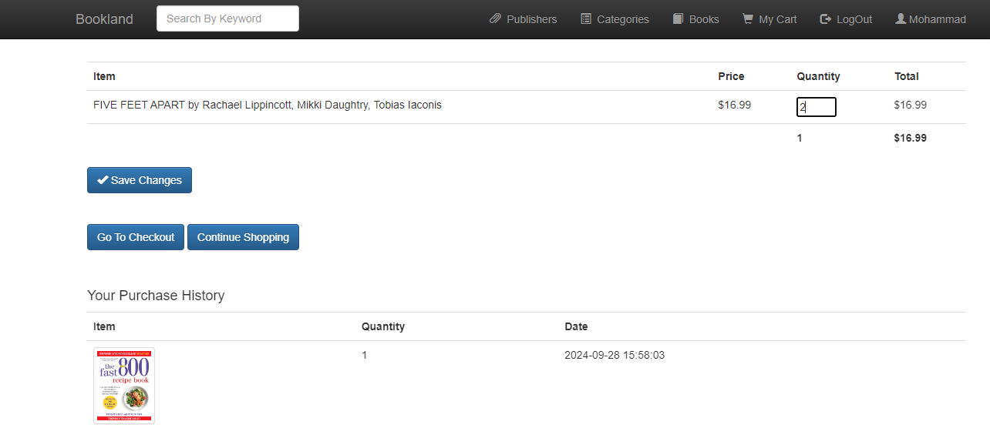

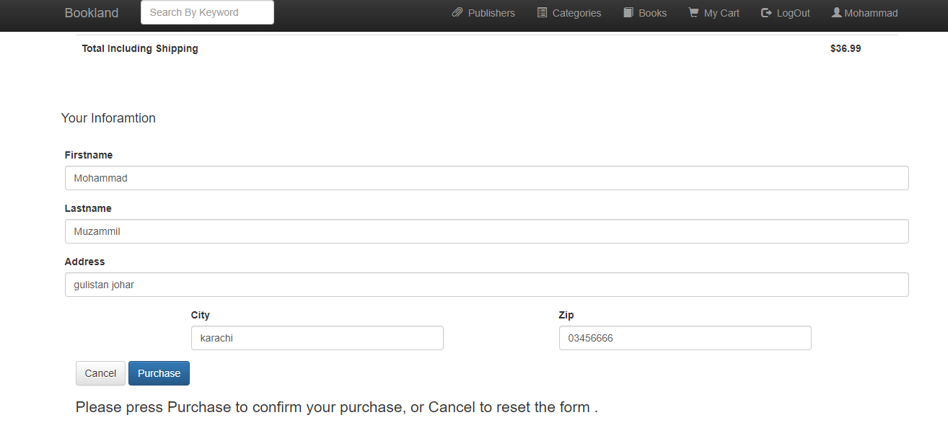

**Admin Penal:**

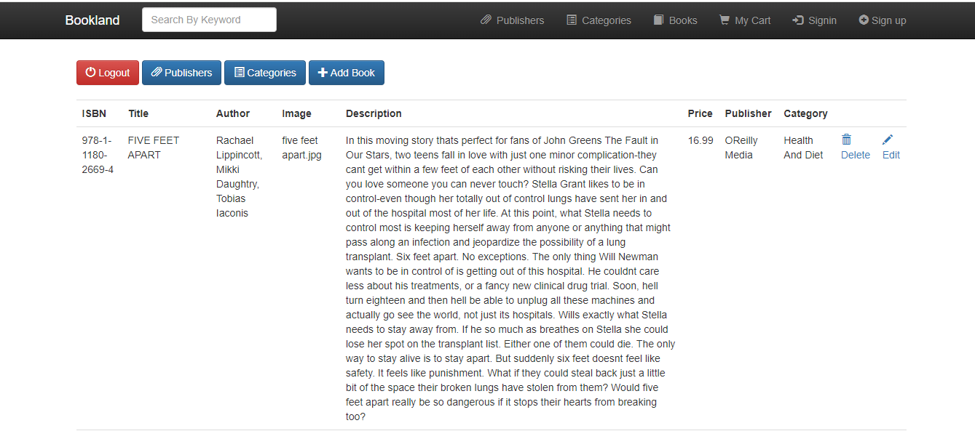

**Publisher:**

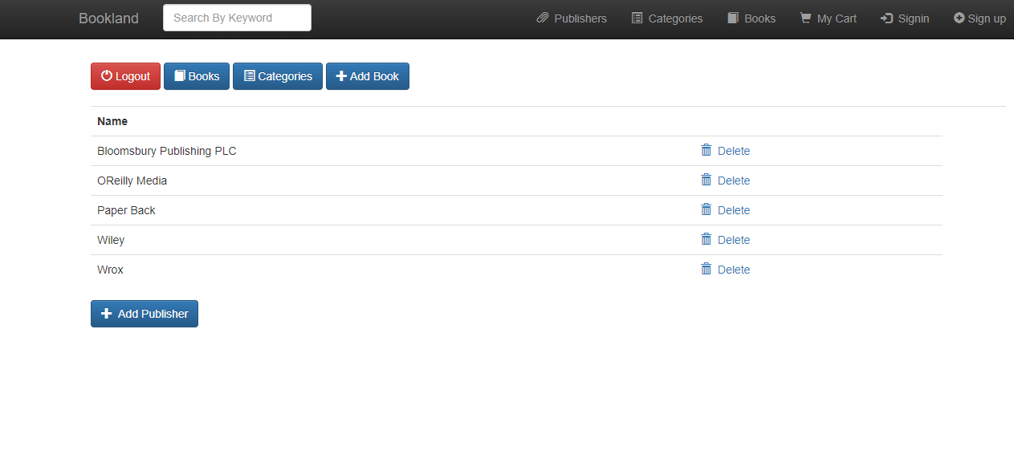

**Add New Book:**

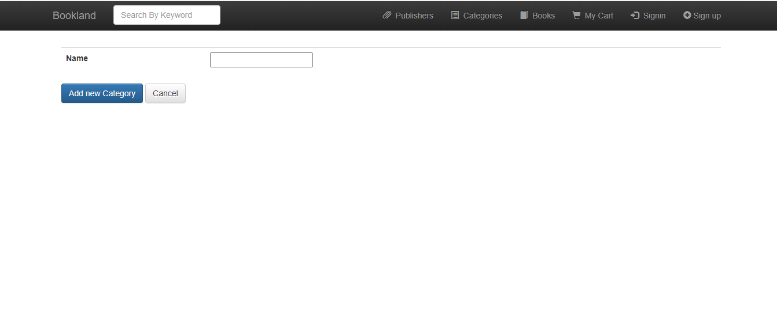

**Add New Category:**

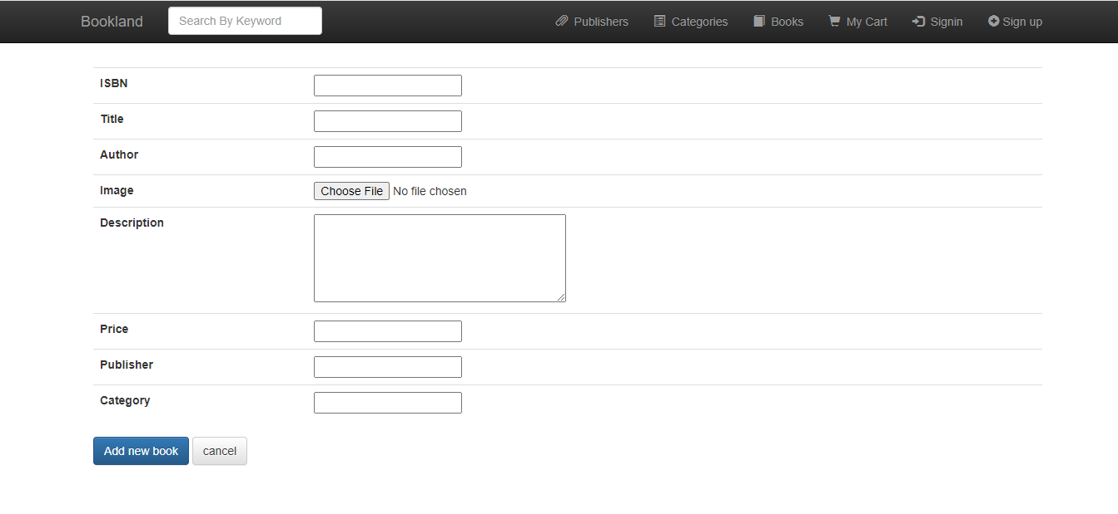

**Source Code:**

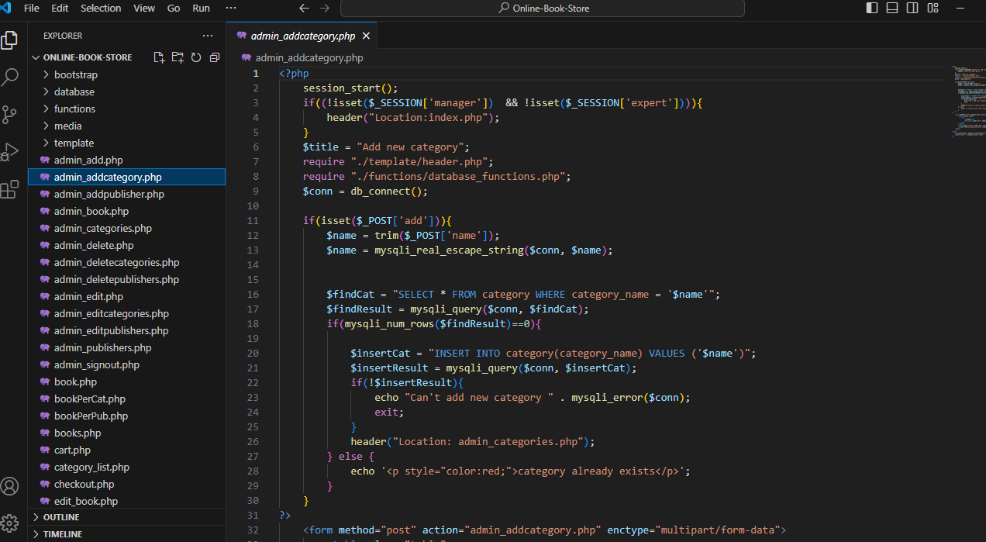

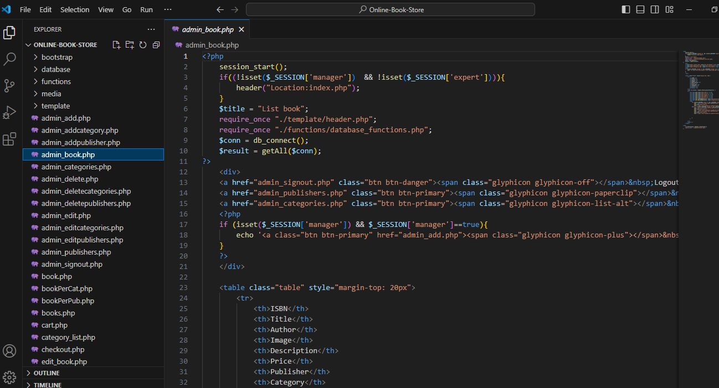

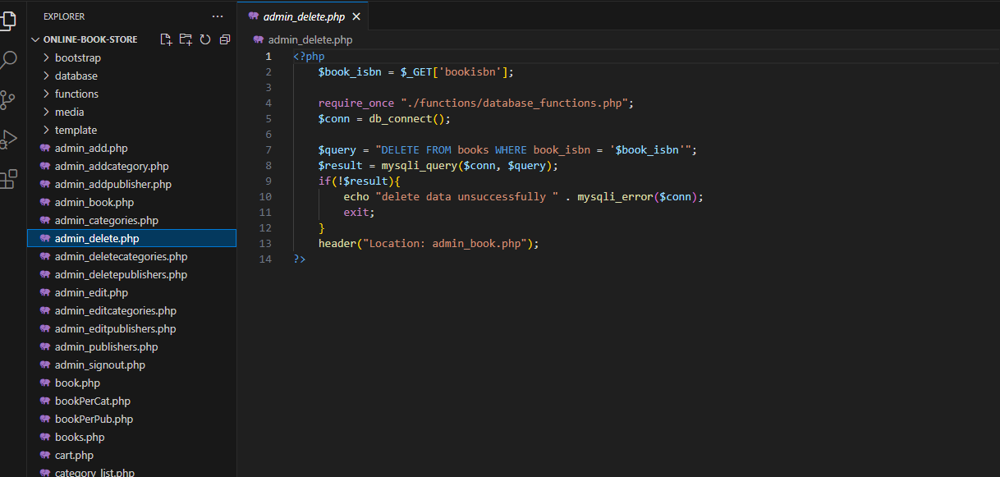

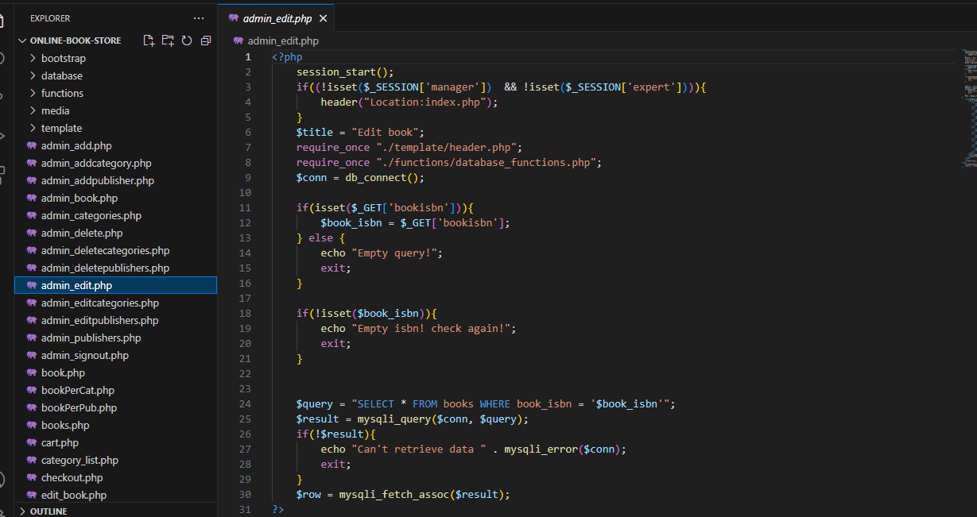

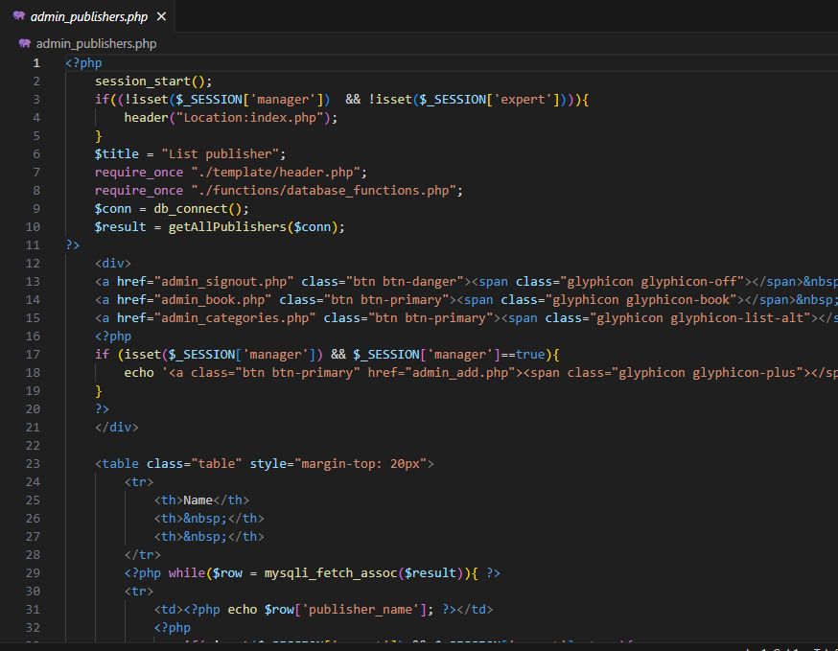

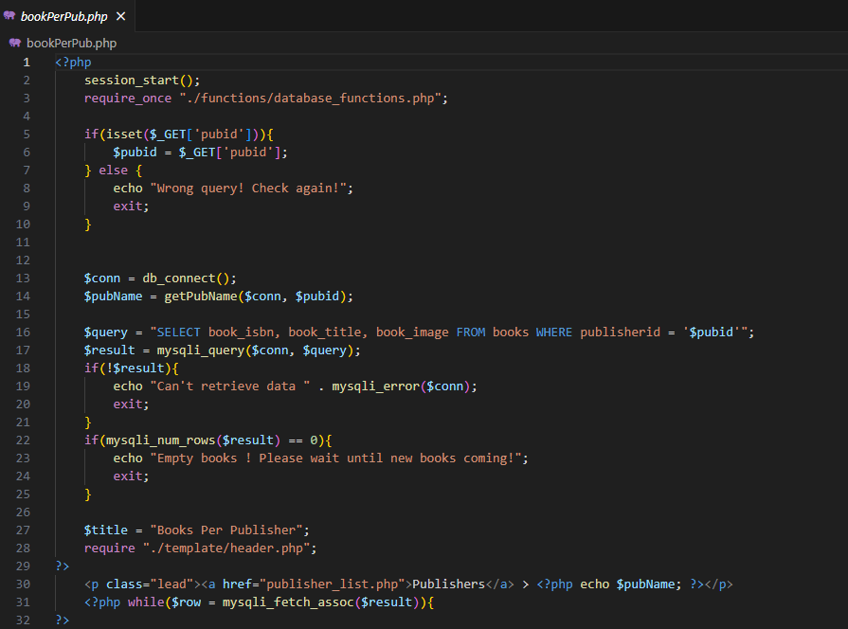

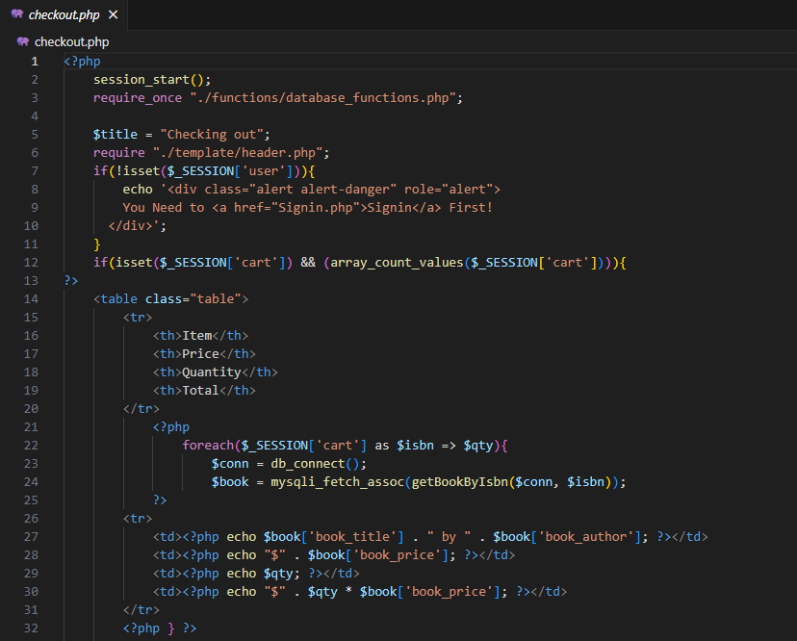

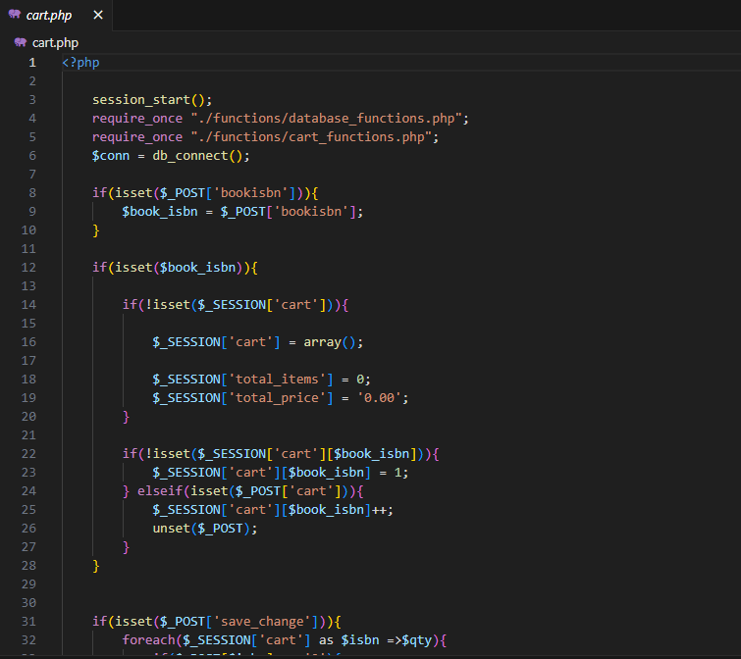

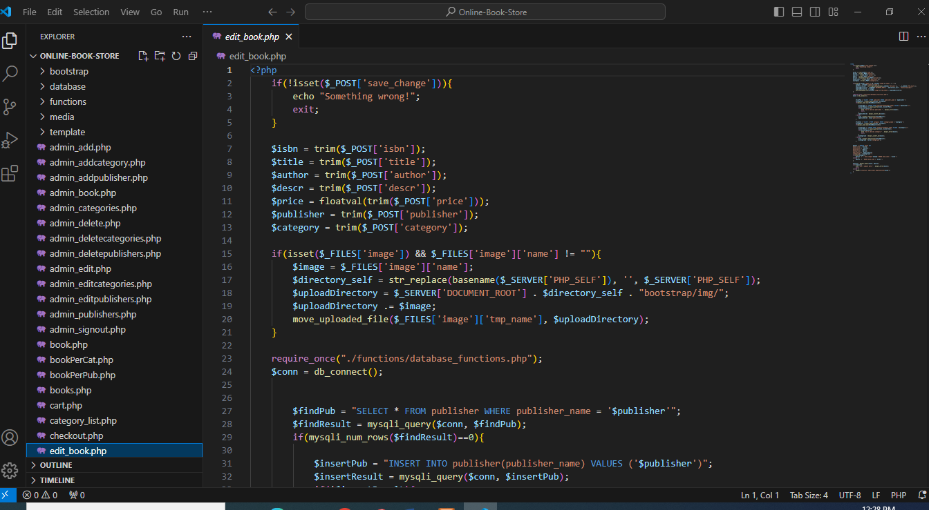

## Benefits of Online Bookstores

Online bookstores have revolutionized the way we access and purchase books. Here are some of the key benefits they offer:

### Convenience and Accessibility

* **24/7 access:** Shop anytime, anywhere.
* **Wide selection:** Access a vast array of titles, including rare or out-of-print books.
* **Easy search:** Quickly find books by author, title, genre, or subject.

### Cost-Effective

* **Competitive pricing:** Often offer lower prices than traditional bookstores.
* **Discounts and deals:** Benefit from frequent sales, promotions, and coupons.
* **Free shipping:** Enjoy free shipping on eligible orders.

### Personalized Experience

* **Recommendations:** Receive personalized book suggestions based on your reading history.
* **Reviews and ratings:** Read reviews from other customers to make informed choices.
* **Wishlists:** Create and share wishlists with friends and family.

### Time-Saving

* **No need to travel:** Avoid the hassle of going to a physical store.
* **Quick checkout:** Complete your purchase in a few clicks.
* **Instant gratification:** Receive your books quickly through efficient shipping.

### Eco-Friendly

* **Reduced carbon footprint:** Contribute to environmental sustainability by reducing the need for physical stores and transportation.
* **Digital options:** Choose digital formats (e-books, audiobooks) to eliminate physical waste.

Overall, online bookstores offer a convenient, affordable, and personalized way to discover and purchase books. Whether you're a casual reader or a bookworm, there's something for everyone.

### Database Design:

The database schema will include tables for:

* **Users:** Store user information (username, email, password, etc.).
* **Books:** Store book details (title, author, description, price, image, etc.).
* **Categories:** Organize books into categories (e.g., fiction, non-fiction, genre).
* **Orders:** Record order information (customer ID, book details, quantity, total price, status).
* **Order Items:** Store individual items within an order.
* **Reviews:** Allow users to rate and review books.

### Development Process

1. **Planning and Design:** Create a detailed project plan, including wireframes and mockups for the user interface.
2. **Database Setup:** Set up the MySQL database and create the required tables.
3. **Server Configuration:** Configure the web server (Apache or equivalent) to serve PHP files.
4. **Development:** Write PHP code to implement the various features of the online bookstore.
5. **Testing:** Thoroughly test the application to ensure functionality and identify any bugs.
6. **Deployment:** Deploy the application to a web server for public access.

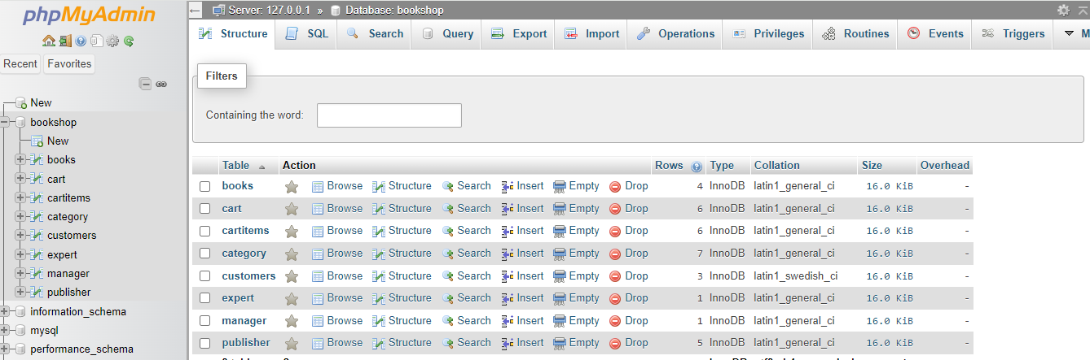

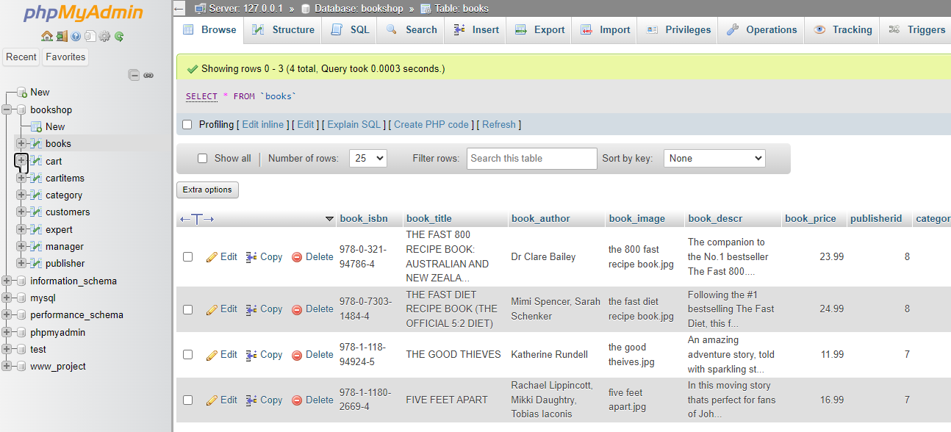

### ****Conclusion:****

The online bookstore project provides a valuable platform for users to discover, purchase, and enjoy books. By following the outlined system requirements, architecture, functionality, and development methodology, this project can be successfully implemented to meet the needs of both users and business owners.

**\*\*\*\*\*\*\*\*\*\*Thank You\*\*\*\*\*\*\*\*\*\***